
VILNIUS GEDIMINas Technical university
Faculty of Electronics
department of Electrnics systems

Machine Learning
Practical work 4
Authors: Kirill Postrehan, EDIfu 24/1
Lecturer: Dr. Olusola Oluwakemi Abayomi Alli

VILNIUS 2026
Introduction:
In this practical work I will apply various data preprocessing methods on Adult Census Income Dataset.
Analysis & visualizations:
First things first. I found out that there in many cells you can find sign ?, so in order to remove it a raplaced it with NaN. After that I found duplicated in the dataset and dropped them. While looking at the data I noticed that there are two rows that consist mostly of zeros: capital.gain with 92% and capital.gain with 95% of zeros.
Then I applied different methods of imputation on null data.
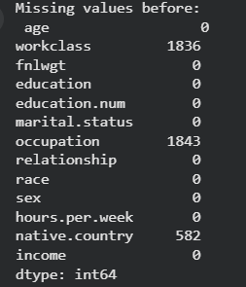
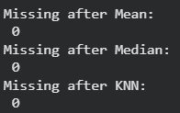
In the next task I had to normalize data using MinMaxScaler and Z-score methods and got the following results:
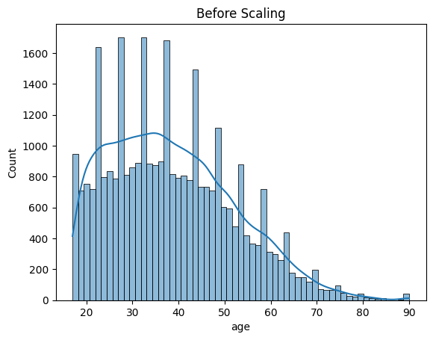
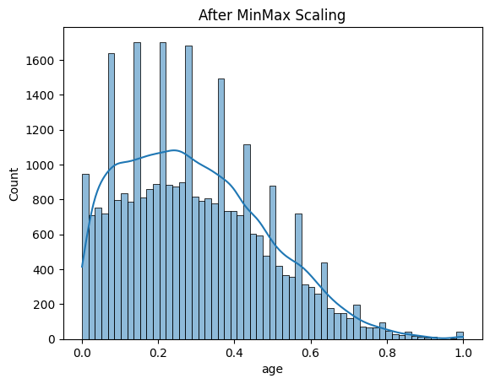
After this method our data is in [0.0, 1.0]
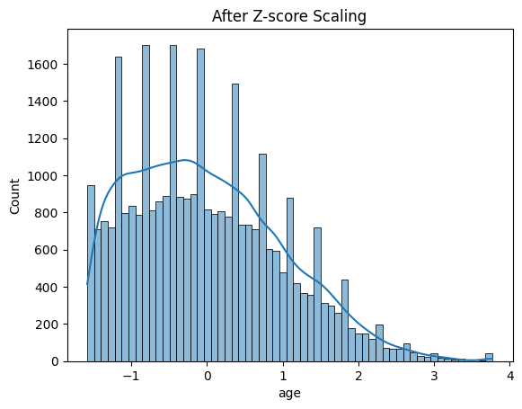
After this method our data is range from -1.21 to 3.77
The next task implies standardizing features using PCA:
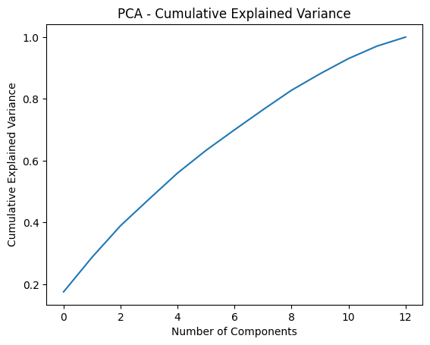
This plot shows us how much principal components preserve information.
Then I had to discretize data using equal-width binning, equal-frequency binning and KMeans cluster discretization. For that I specified 5 bins or 5 clusters for KMeans and here are results:
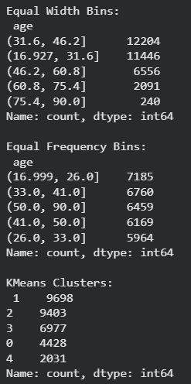
Finally, I made a train test split on the results data, where 20% of which will be used for testing:
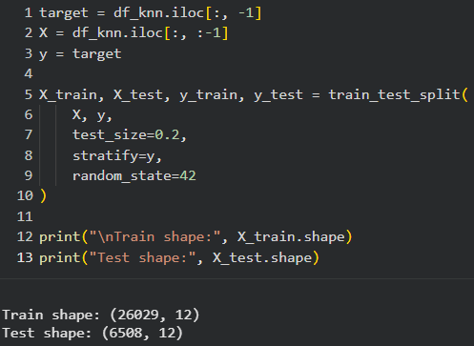
Conclusion:
In this work, the Adult Census Income dataset was preprocessed by handling missing values, removing duplicates, and applying imputation. The data was then normalized using MinMax scaling and Z-score standardization. PCA was used to analyze variance preservation, and discretization methods (equal-width, equal-frequency, and KMeans) were applied. Finally, the dataset was split into training and testing sets (80/20) to prepare it for machine learning tasks.

